­**Full Proposal Project Narrative**

**Instructions:** Save this document on your computer and complete the narrative in the format provided. The final narrative should not exceed eight (8) pages; do not delete the headings provided below. Once complete, upload this document into the online application as instructed.

1. **Activities:** List the main activities that will be employed through the grant with distinct headings and elaborate on the methodology and the expected progress within the grant period. These headings will be used as the format for interim and final progress reporting. Please link all activities to expected outcome(s) of the project and describe how they relate to established plans (management, conservation, recovery, etc.) and priority conservation needs in the specific project location.

Project objectives:

1. Build capacity on-island for continued assessment of key parameters related to mitigation of sediment loading to the coast in American Samoa.

1. Measure key parameters continuously (rainfall, streamflow, turbidity) during one fiscal year (July 2015-May 2016) at as specific field site where there has been significant mitigation activities for sediment generated by an open pit quarry (Faga’alu watershed).
2. Quantify the effectiveness of the mitigation activities at the quarry in reducing sediment concentrations and loads to the coast for a) the ratio of sediment flux pre- and post-mitigation and b) how close the sediment load is to undisturbed conditions above the stream.

Turbidity and stream flow are currently measured at three locations in Faga’alu watershed, and precipitation is recorded at two locations (Figure 1):

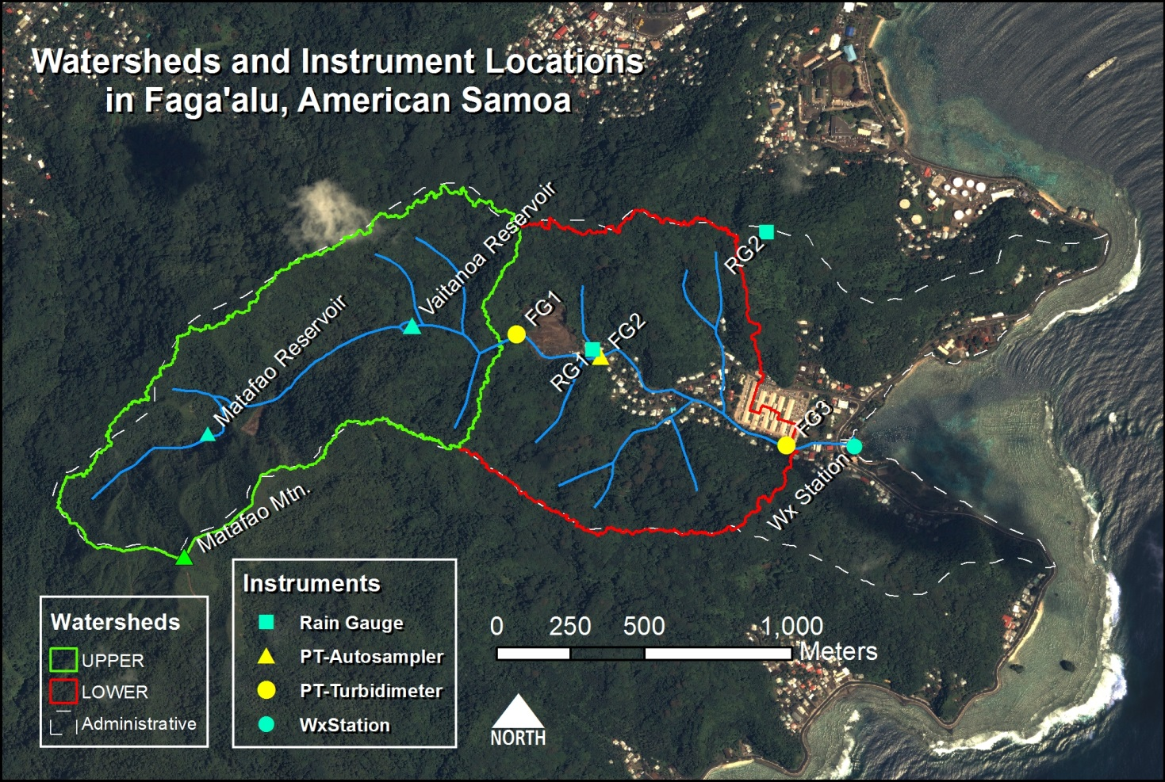

*Figure 1. Faga'alu watershed showing sampling sites and instrumentation at three locations: the watershed above FG1 is largely undisturbed; FG2 is immediately downstream of the quarry, and FG3 is in the village at the stream outlet to the ocean. The instruments will be maintained and data downloaded by ASEPA.*

The equipment installed includes the following:

* + 1 automatic recording weather station
  + 2 Rainwise tipping-bucket rain gauges with HOBO event loggers
  + 1 Solinst Barologger barometric pressure recorder
  + 2 non-vented Levelogger pressure transducers
  + 2 ISCO 3000 Autosamplers
  + 3 Turbidimeters:
    - 2 Cambell Scientific OBS500
    - 1 YSI Environmental 600 OMS sonde with 6136 turbidity probe

The overall strategy is to train ASEPA personnel how to download the data from the instruments, how to setup the Autosampler and process samples, and how to perform basic equipment maintenance. SDSU will also train ASEPA in data analysis, and SDSU will prepare the final report documenting the effectiveness of the mitigation activities.

The project activities include:

1. **Preparation of field manual**

A simplified field manual for equipment maintenance and field techniques will be prepared for use in Faga’alu watershed (Messina, June 2015). The manual will include information on maintenance and details on how to download data for:

1. Rain gauge and HOBO event data loggers
2. Levellogger pressure transducers
3. Turbidimeters
4. Autosampler (ISCO 3000) and suspended sediment concentration analysis in the lab
5. Weather station

While manuals are available from the manufacturer for these items, they often contain extraneous information not relevant to a particular site, and the information is are scattered in several different documents, complicating efficient access during fieldwork. This manual will provide only the essential information needed for equipment maintenance and downloading data in the field for use by ASEPA personnel.

1. **Workshop in American Samoa**

Project PI (Biggs) and PhD student (Alex Messina) will be on-island in June or July 2015 to host a workshop that will train ASEPA on downloading data, equipment maintenance, and sample analysis for suspended sediment concentration (June/July 2015).

1. **Data download for one year**

Data on turbidity, stream level, and rainfall will be downloaded monthly by ASEPA between July 2015 and May 2016, and the data will be emailed to the SDSU PI for analysis and archiving. The data will be made available on a GitHub server and all project personnel will have access to the final dataset and software used to generate the final plots.

1. **Equipment maintenance**

* The turbidimeter will be calibrated every 6 months by ASEPA.
* The turbidimeter probe surfaces will be wiped cleaned and cleared of debris as often as possible
* The turbidimeter wipers must be inspected for sediment clogging or other malfunctions monthly
* Autosampler bottles must be cleaned of any algae growth or sediment buildup whenever samples are removed
* The battery levels in all equipment with batteries will be assessed and batteries replaced as needed.

1. **Technical support**

Technical support will be provided by SDSU for ASEPA monitoring from July 2015-May 2016.

1. **Storm sampling**

Two Autosamplers will be deployed by SDSU and maintained by ASEPA downstream of the quarry (FG2), and at the LBJ hospital (FG3) to collect samples for at least 3-5 storms. Water samples will be analyzed for suspended sediment concentration on-island. The samples will be used to update the calibrated relationship between turbidity and suspended sediment concentration.

1. **Final report**

A final report will be prepared by SDSU that quantifies the effectiveness of the mitigation activities on reducing sediment load for different size storms. See “5. Tracking metrics” for details of the methodology used to assess effectiveness.

1. **Outcome(s):** Elaborate on the outcome(s) summarized previously in the application; discuss what makes this outcome(s) achievable and important. Outcomes should be specific and measurable. Outcomes that will not be achieved within the grant period but are anticipated as a direct result of the grant should also be described. If the project period is >18 months a bulleted list of annual milestones toward progress to outcomes is required.
2. **Training materials:** A simplified field manual for equipment maintenance and field techniques for use in Faga’alu watershed. The manual is important for capacity building for assessment of mitigation activities on suspended sediment, both at Faga’alu and elsewhere.
3. **On-site capacity building:** One 3-day workshop in American Samoa to train ASEPA personnel on equipment maintenance and field techniques. The outcome will be measured using workshop exercises where ASEPA personnel will carry out all required maintenance and data downloads without assistance.
4. **Data sets for effectiveness evaluation**: Time series of rainfall, discharge, turbidity, and suspended sediment concentration at three locations in Faga’alu watershed, July 2015-May 2016.
5. **Report evaluating effectiveness:** Report documenting the effectiveness of the mitigation activities. See “5. Tracking metrics” for details of the methodology used to assess effectiveness.
6. **Tracking Metrics:** Indicate how the project will monitor/assess progress on the metrics selected previously in the application. Please note any challenges or limitations anticipated with tracking the metrics.

**Capacity building and data collection:** Progress in capacity building will be documented by workshop exercises where ASEPA personnel will carry out all required maintenance and data downloads without assistance. The data collection activities following the workshop will be monitored through monthly email communication between ASEPA and SDSU with the data collected. SDSU will assess the data for quality and correspond with ASEPA about any potential issues.

**Effectiveness of the mitigation activities**: Effectiveness of mitigation activities at the quarry will be assessed using storm-total sediment yield (SSY) calculated from in stream measurements of stream discharge and suspended sediment concentration (estimated using turbidity). Previous research shows SSY is highly dependent on stream peak discharge during the storm:

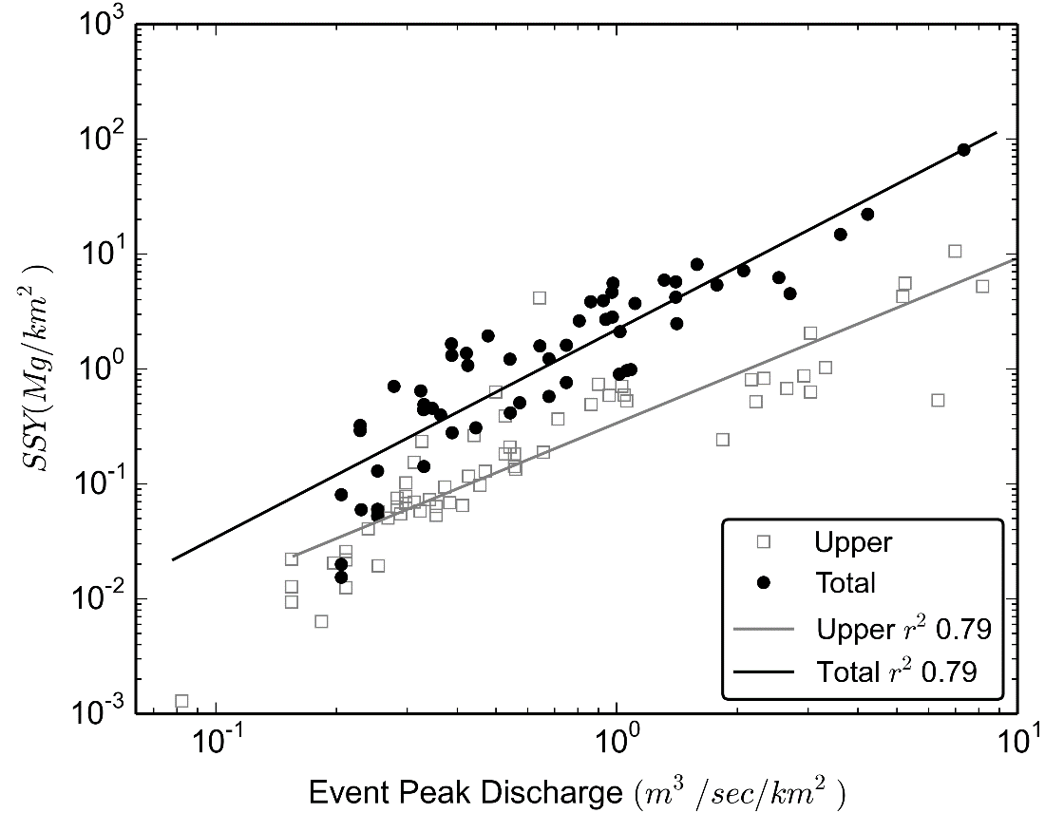

*Figure 2. Relationship between the peak event during a storm event (x-axis) and the suspended sediment yield (SSY, Mg (tons) per km2) in Faga’alu. The “total” points show the SSY at the Village site, and the open squares are of the upper, forested watershed.*

The data collected to date will provide the baseline for assessing the effectiveness of mitigation activities. The percent reduction in SSY for a given storm size will be calculated from the newly collected data. Mitigation will be deemed successful if the points below the quarry are within the 95% confidence limits of the relationship for the upper, forested watershed.

1. **Project Team:** List key individuals and describe their qualifications relevant for project implementation.

Dr. Trent Biggs, Department of Geography, San Diego State University. Dr. Biggs has 18 years of experience in hydrology and water quality analysis. He has supervised work of SDSU students in American Samoa since 2011, including for project scientists Alex Messina.

Alex Messina, Department of Geography, San Diego State University.

Chrisianera Tuitele, American Samoa Environmental Protection Agency

Jewel Potoae, American Samoa Environmental Protection Agency

1. **Representative Project Photos:** Via the Uploads section of the proposal, please include 1-5photos of the project location or activities. Photos should be numbered 1-5 and require a minimum resolution of 300 dpi.  For each uploaded photo, provide a photo credit and brief description below.

Photo 1: LEFT: CampbellSci OBS500 turbidimeter installed at FG2, downstream of the quarry. The turbidimeter is mounted on a metal pole in the stream, and connected to the battery and data logger in the white enclosure mounted to the pole. A solar panel charges the battery. The ISCO Autosampler is installed in the brown box to collect simultaneous stream samples with turbidimeter readings. RIGHT: A laptop is connected to the data logger to collect data.

Photo 2: TOP: The open aggregate quarry in Faga'alu in 2012, BOTTOM: and 2014 prior to installation of retention ponds.

Photo 3: LEFT: The quarry in 2014, prior to retention pond installation. RIGHT: A large mound of overburden was removed in 2014 and retention ponds installed.

Photo 4: Retention ponds were installed in October 2014 and are now fully operational.

Photo 5: LEFT: During storm periods, natural sediment yield from upstream of the quarry can be high. RIGHT: Large storms fill the retention ponds, and overflow is routed into the stream through a standpipe. However, the small amount of sediment from the overflow is less than the natural yield.

*Example — Photo 1: John Smith, NFWF. Photo of the current eroded area to be addressed by plantings.*

1. **Other (Optional):** Provide any further information important for the review of this proposal.Project site maps and letters of support are preferred but not required.